**Distribute Your App Across a Swarm Cluster**

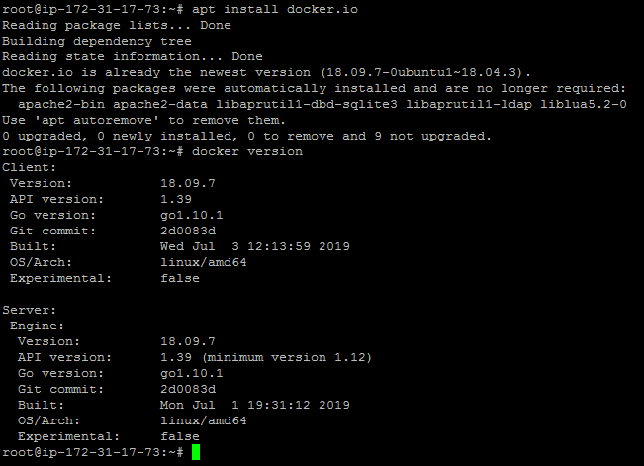

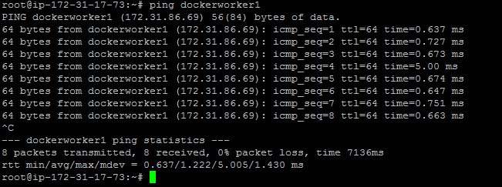

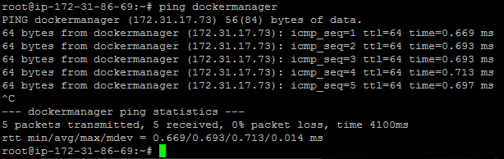

docker swarm init --advertise-addr<manager node IP address>

docker swarm init --advertise-addr172.31.17.73

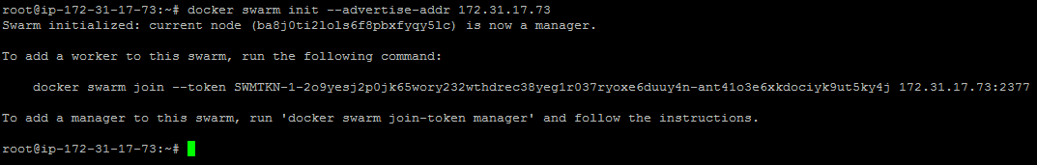

* Once the swarm cluster is initialized, allow the ports mentioned below in security groups







